The Guilt of Mankind

Romans One

Scripture Reading: Rom. 1:18-32

Introduction:

- A chart from the old college press commentary on Romans.
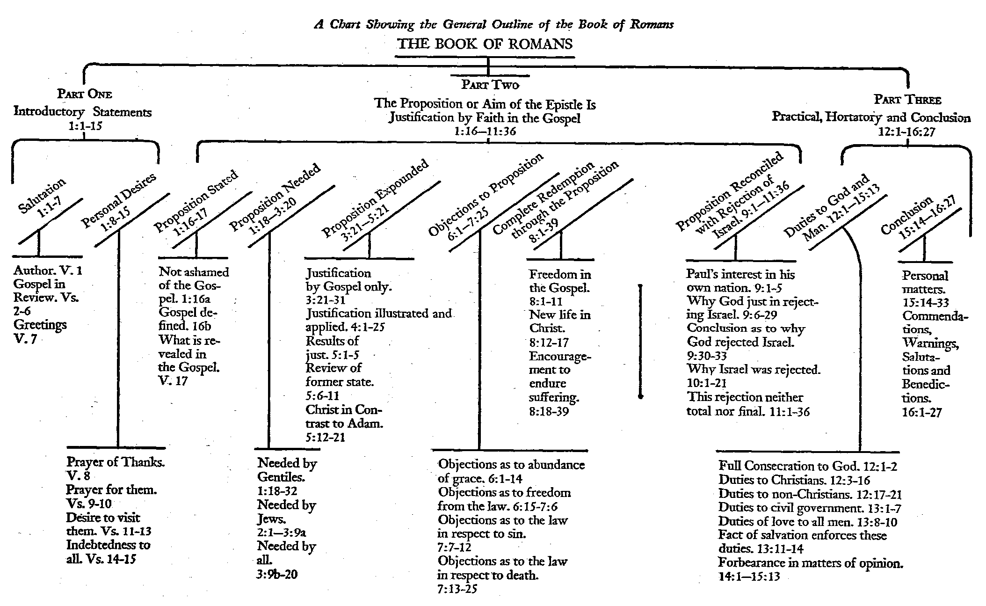 (Romans, College Press)
- The book of Romans gives every Christian the hope of Justification through faith.

- The Apostles Commission (Romans 1:1-7).

Romans 1:1-7 KJVR
(1) Paul, a servant of Jesus Christ, called to be an apostle, separated unto the gospel of God,
(2) (Which he had promised afore by his prophets in the Holy Scriptures,)
(3) Concerning his Son Jesus Christ our Lord, which was made of the seed of David according to the flesh;
(4) And declared to be the Son of God with power, according to the spirit of holiness, by the resurrection from the dead:
(5) By whom we have received grace and apostleship, for obedience to the faith among all nations, for his name;
(6) Among whom are ye also the called of Jesus Christ:
(7) To all that be in Rome, beloved of God, called to be saints: Grace to you and peace from God our Father, and the Lord Jesus Christ.

  - The Calling of Paul (1).
    - “a servant of Jesus Christ”
      - The Greek word doulos, (δοῦλος) comes from the word deo, (δέω) which means to bind.
        - This is a generic term applied to anything which can be bound, tied, or fettered.
        - Thayer Definition:

1) a slave, bondman, man of servile condition
1a) a slave
1b) metaphorically, one who gives himself up to another’s will those whose service is used by Christ in extending and advancing his cause among men
1c) devoted to another to the disregard of one’s own interests

2) a servant, attendant
        - “He was a bond-man, and hence not free; he owned not himself, nor controlled his own acts. He was bound by the will of another.”
      - All Christians share this title.
        - Jesus taught his disciples to be bond servants.
Mat 10:25 KJVR
(25) It is enough for the disciple that he be as his master, and the servant as his lord. If they have called the master of the house Beelzebub, how much more shall they call them of his household?

Mat 20:27 KJVR
(27) And whosoever will be chief among you, let him be your servant:

Mar 10:44 KJVR
(44) And whosoever of you will be the chiefest shall be servant of all.

        - The term was also used by Christians.
Gal 1:10 KJVR
(10) For do I now persuade men, or God? or do I seek to please men? for if I yet pleased men, I should not be the servant of Christ.

Col 4:12 KJVR
(12) Epaphras, who is one of you, a servant of Christ, saluteth you, always laboring fervently for you in prayers, that ye may stand perfect and complete in all the will of God.

        - This title was used in the Old Testament to designate the Prophets.
Jer 44:4 KJVR
(4) Howbeit I sent unto you all my servants the prophets, rising early and sending them, saying, Oh, do not this abominable thing that I hate.

      - We are slaves who have been liberated by binding ourselves to Christ.
        - We are free to do what is right.
        - We are free from the burden of sin.
        - We are free from the sting of death.
    - “apostle”
      - The Greek word is apostello (ἀπόστολος), which literally means one sent from, sent out, or sent away.
      - Paul was not called by men like Matthias, but was called directly by Jesus.
      - He was chosen by Jesus for a special purpose.
    - “set apart”
      - “The word aphorize (ἀφορίζω), primarily means to separate one thing from another by drawing a boundary-line between them.”
      - The line drawn was for the purpose of separating Paul from the world and “to the gospel of God.”
      - Paul was “separated” both by God (Gal. 1:15) and by the Church at Antioch (Acts 13:2), to preach the Gospel.
Gal 1:15-16 KJVR
(15) But when it pleased God, who separated me from my mother's womb, and called me by his grace,
(16) To reveal his Son in me, that I might preach him among the heathen; immediately I conferred not with flesh and blood:

Act 13:2 KJVR
(2) As they ministered to the Lord, and fasted, the Holy Ghost said, Separate me Barnabas and Saul for the work whereunto I have called them.

  - The Conviction of Paul (2-4).
    - Born of the seed of David according to the (his) flesh.
      - “(It is) his joyful proclamation of the victory and exaltation of his Son, and the consequent amnesty and liberation which we may enjoy through faith in him.” (F.F. Bruce)
      - The Fact that Jesus was born of the seed of David gives him affirmation.
        - His humanity
Luk 1:27 KJVR
(27) To a virgin espoused to a man whose name was Joseph, of the house of David; and the virgin's name was Mary.

Luk 2:4 KJVR
(4) And Joseph also went up from Galilee, out of the city of Nazareth, into Judea, unto the city of David, which is called Bethlehem; because (he was of the house and lineage of David:)

        - His royal pedigree
2Sa 7:12 KJVR
(12) And when thy days be fulfilled, and thou shalt sleep with thy fathers, I will set up thy seed after thee, which shall proceed out of thy bowels, and I will establish his kingdom.

Psa 132:11 KJVR
(11) The LORD hath sworn in truth unto David; he will not turn from it; Of the fruit of thy body will I set upon thy throne.

        - His completion of prophecy
      - “Christ is the Hope of Israel, the Light of the Gentiles, the Lily of the Valley, the Bright and Morning Star, the Fairest of Ten Thousand, Wonderful, Counselor, Mighty God, Everlasting Father, Prince of Peace!” (Coffman)
    - Declared to be the Son of God
      - His declaration was made with power!
        - “With power - εν δυναμει, With a miraculous display of Divine energy; for, how could his body be raised again, but by the miraculous energy of God? Some apply the word here to the proof of Christ’s sonship; as if it were said that he was most manifestly declared to be the Son of God, with such powerful evidence and argument as to render the truth irresistible.” (Clark)
        - Jesus was anointed with power.
Act 10:38 KJVR
(38) How God anointed Jesus of Nazareth with the Holy Ghost and with power: who went about doing good, and healing all that were oppressed of the devil; for God was with him.

        - He was given all power.
Mat 28:18 KJVR
(18) And Jesus came and spake unto them, saying, All power is given unto me in heaven and in earth.

        - He is coming back with power.
Mat 24:30 KJVR
(30) And then shall appear the sign of the Son of man in heaven: and then shall all the tribes of the earth mourn, and they shall see the Son of man coming in the clouds of heaven with power and great glory.

      - His declaration was made through the spirit of holiness.
        - “His divine nature: Declared to be the Son of God (Rom_1:4), the Son of God by eternal generation, or, as it is here explained, according to the Spirit of holiness. According to the flesh, that is, his human nature, he was of the seed of David; but, according to the Spirit of holiness, that is, the divine nature (as he is said to be quickened by the Spirit, 1Pe_3:18, compared with 2Co_13:4), he is the Son of God.” (Henry)
        - Jesus was God!
Joh 1:1 KJVR
(1) In the beginning was the Word, and the Word was with God, and the Word was God.

        - It was through the power of the Holy Spirit that the gospel was spread.

      - His declaration was affirmed through his resurrection.
        - It is because of Christ resurrection that all believers will be raised.
        - “when God raised him up therefore, it was not an ordinary event. It was “a public attestation, in the face of the universe, of the truth of his claims to be the Son of God.” God would not sanction the doings and doctrines of an impostor. And when, therefore he raised up Jesus, he, by this act, showed the truth of his claims, that he was the Son of God.” (Barnes)

    - We have received from him grace and apostleship.
      - The word “we,” refers to Paul and other apostles.
      - Paul, along with the rest of the apostles, was commissioned by the grace of God, to spread the Gospel.
      - It was “through” Jesus and his power and authority that this commission was proclaimed.
  - The Commission of Paul (5-7).
    - Obedience of the faith.
      - This is the first time the word faith is mentioned in the book of Romans.
      - The faith that Paul will be writing about in this book is introduced as “obedient faith.”
      - Paul not only introduces his book of faith defined through obedience but he also ends in the final doxology with the same phrase (“obedience of faith”).
Rom 16:26 KJVR
(26) But now is made manifest, and by the Scriptures of the prophets, according to the commandment of the everlasting God, made known to all nations for the obedience of faith:

    - All the nations.
      - Those who are obedient to the faith,
      - The Romans among them.
      - Those who belong to Jesus
    - Greetings to those in Rome.
      - Beloved of God.
      - Called saints.
      - Grace and peace to you from God our Father and the Lord Jesus Christ

- The Apostles Concern (Romans 1:8-13).

Romans 1:8-15 KJVR
(8) First, I thank my God through Jesus Christ for you all, that your faith is spoken of throughout the whole world.
(9) For God is my witness, whom I serve with my spirit in the gospel of his Son, that without ceasing I make mention of you always in my prayers;
(10) Making request, if by any means now at length I might have a prosperous journey by the will of God to come unto you.
(11) For I long to see you, that I may impart unto you some spiritual gift, to the end ye may be established;
(12) That is, that I may be comforted together with you by the mutual faith both of you and me.
(13) Now I would not have you ignorant, brethren, that oftentimes I purposed to come unto you, (but was let hitherto,) that I might have some fruit among you also, even as among other Gentiles.

  - The Appreciation of Paul (8).
    - His thanksgiving
      - Thankful to God.
      - Thankful through Jesus Christ.
      - Thankful for them.
    - Their Faith.
      - Their faith caused Paul to be thankful.
      - Their faith was proclaimed.
      - Their faith reached the whole world.
  - The Appeal of Paul (9-12).
    - Paul’s servitude.
    - Paul’s prayer.
    - Paul’s desire.
  - The Aspiration of Paul (13).
    - Produce faith in the Romans.
    - Produce fruit in the Romans.
    - Produce faith in other Gentiles

- The Apostles Confidence (Romans 1:14-17).

Romans 1:14-17 KJVR
(14) I am debtor both to the Greeks, and to the Barbarians; both to the wise, and to the unwise.
(15) So, as much as in me is, I am ready to preach the gospel to you that are at Rome also.
(16) For I am not ashamed of the gospel of Christ: for it is the power of God unto salvation to every one that believeth; to the Jew first, and also to the Greek.
(17) For therein is the righteousness of God revealed from faith to faith: as it is written. The just shall live by faith.

  - Paul preached because of what we Christians are (14).
    - Trustees of the Gospel.
    - Debtors to all men.
    - Ambassadors of Christ.
  - Paul preached because of what man is (15).
    - A sinner.
  - Paul preached because of what the Gospel is (16).
    - The good news.
    - God’s power unto salvation.
  - Paul preached because of what God is (17).
    - A holy savior.
    - A just savior.
    - An unchanging savior.

- The Apostles Condemnation (Romans 1:18-32).

Romans 1:18-32 KJVR
(18) For the wrath of God is revealed from heaven against all ungodliness and unrighteousness of men, who hold the truth in unrighteousness;
(19) Because that which may be known of God is manifest in them; for God hath showed it unto them.
(20) For the invisible things of him from the creation of the world are clearly seen, being understood by the things that are made, even his eternal power and Godhead; so that they are without excuse:
(21) Because that, when they knew God, they glorified him not as God, neither were thankful; but became vain in their imaginations, and their foolish heart was darkened.
(22) Professing themselves to be wise, they became fools,
(23) And changed the glory of the incorruptible God into an image made like to corruptible man, and to birds, and fourfooted beasts, and creeping things.
(24) Wherefore God also gave them up to uncleanness through the lusts of their own hearts, to dishonor their own bodies between themselves:
(25) Who changed the truth of God into a lie, and worshiped and served the creature more than the Creator, who is blessed forever. Amen.
(26) For this cause God gave them up unto vile affections: for even their women did change the natural use into that which is against nature:
(27) And likewise also the men, leaving the natural use of the woman, burned in their lust one toward another; men with men working that which is unseemly, and receiving in themselves that recompense of their error which was meet.
(28) And even as they did not like to retain God in their knowledge, God gave them over to a reprobate mind, to do those things which are not convenient;
(29) Being filled with all unrighteousness, fornication, wickedness, covetousness, maliciousness; full of envy, murder, debate, deceit, malignity; whisperers,
(30) Backbiters, haters of God, despiteful, proud, boasters, inventors of evil things, disobedient to parents,
(31) Without understanding, covenant breakers, without natural affection, implacable, unmerciful:
(32) Who knowing the judgment of God, that they which commit such things are worthy of death, not only do the same, but have pleasure in them that do them.

  - The Culpability of Mankind (18-23).
  - The Curse of Mankind (24-25).
  - The Corruption of Mankind (26-32).

Don DeWelt, Romans Realized,. College Press, Joplin.MS
Lard. Romans. P.24
Lard. Romans. P. 25.
F. F. Bruce, The Epistle of Paul to the Romans (Grand Rapids, Michigan: Wm. B. Eerdmans Publishing Company, 1963), p. 7.
James Coffman, Romans (A.C.U. Press, 1973), p. 6-7.
Clark
Mathew Henry’s Commentary on the Whole Bible
Albert Barnes’ Notes on the Bible

